|  |
| --- |
| Software Engineering Project |
| Electronic Health Record System |
| Requirements Report |
|  |
|  |
|  |

**05120000238 – Murat Can ÜSTE**

**05120000251 – Nagihan KALAYCI**

**05130000247 – Bilge ULUSAY**

**Contents**

1 Introduction 2

2 Identification of Viewpoints 3

2.1 Principal Viewpoints of the System 3

2.1.1 Interactor Viewpoints 3

2.1.2 Indirect Viewpoints 3

2.1.3 Domain Viewpoints 4

2.2 Viewpoint Hierarchy Diagram 5

2.3 Requirements of each Viewpoint 6

2.3.1 Requirements of the Interactor Viewpoints 6

2.3.2 Requirements of the Indirect Viewpoints 6

2.3.3 Requirements of the Domain Viewpoints 7

3 Requirements Definition 7

3.1 Functional Requirements 7

3.2 Non-Functional Requirements 7

3.3 Domain Requirements 7

3.4 Volatile Requirements 8

3.5 Enduring Requirements 8

4 Requirements Interviews with Domain Experts 9

5 Requirements Prioritization and Negotiation 10

6 Requirements Traceability Matrix 11

7 Use Cases of Main Scenarios 12

8 Domain Model 13

9 Other Schemas 14

# Introduction

The lately technological improvements in information technology (IT) have made a great impact on medical organizations. Today, health information systems are used in virtually every hospital. Health information technologies are used mainly to increase efficiency, quality of service and to reduce costs in hospitals.

*Electronic Health Record System* will provide the doctors and their staff with an electronic copy of the patient file. Personal information and medical information about the patient will be stored and managed by the system. Medical information may consist of any health related information related to a patient. Some important medical information the system supports can be listed as examinations, patient stories, symptoms, tests (blood, urine, etc.), diagnosis, treatments and prescribed medications. The system will also be able to assist physicians in diagnosing and treating a patient by providing diagnosis and treatment recommendations according to the provided information, remind patients of an upcoming event (any appointment, periodic check-up, periodic test, etc.) by sending emails or notifications and track information for billing purposes.

In this document, we specify the stakeholders and the requirements of the system that will be implemented.

# Identification of Viewpoints

## Principal Viewpoints of the System

### Interactor Viewpoints

#### Users

|  |  |
| --- | --- |
| Viewpoint | Description |
| Doctor | Doctors who are responsible for assessing and treating patients. |
| Patient | Patients whose information is recorded in the system. |
| Nurse | Nurses who coordinate the consultations with doctors and administer some treatments. |
| Pharmacist | Pharmacists responsible for the dispensing of prescriptions, also the purchase, manufacture and quality testing of all medicines used in a hospital. |
| Laboratory | Hospital laboratories where tests are done on clinical specimens in order to obtain information about the health of a patient as pertaining to the diagnosis, treatment, and prevention of diesease. |
| Health Technician | Healthcare technicians who are responsible of assisting medical staff complete tasks around their assigned unit or clinic's and accommodate patient needs. |
| Hospital Kitchen | Hostipatl kitchen staff who provide meals to inpatients as per the instructions of the dieticians and physicians. |
| Registration and Admission | Medical receptionists who manage patients’ appointments and registration. |
| Accounting | Accounting Employees who are responsible for accumulating and reporting on financial information about the performance, financial position, and cash flows of the hospital |

#### System Staff

|  |  |
| --- | --- |
| Viewpoint | Description |
| System Administrator | System administrators who are responsible fort the upkeep, configuration, and reliable operation of the system. |
| IT Employee | IT staff who are responsible for installing and maintaining the system related hardware/software. |

### Indirect Viewpoints

|  |  |
| --- | --- |
| Viewpoint | Description |
| Hospital Management | Healthcare managers who obtain management information from the system. |
| Ministry of Health | Ensures that all organisations and institutions that produce health goods and services conform to standards of safety by setting policies, goals, regulations. |
| Ministry of Finance | Responsible for goverment finances, economic policy and financial regulations. |
| Insurance Company | Insurance companies which sell life insurance, annuities and pensions product. |
| Pharmaceutical Company | Pharmaceutical companies which discovers, develops, produces, and markets drugs or pharmaceuticals for use as medications. |

### Domain Viewpoints

|  |  |
| --- | --- |
| Viewpoint | Description |
| Hostpital Rules | Hospital rules and regulations affecting patient care and conduct. |
| Medical Science | Requirements and constraints related to medical science which is a broad term that covers such areas as biochemistry, molecular biology, medicinal chemistry, microbiology, neuroscience, physiology, nutrition, pharmacology, toxicology, vision science and biomedical technology. |
| Medical Data | Requirements and constraints related to compiling and maintaning medical data. |
| Drug Data | Detailed drug data with comprehensive drug target information is needed for the system. |
| Insurance Policy | Domain requirements and constraints related to insurance policies. |

## Viewpoint Hierarchy Diagram

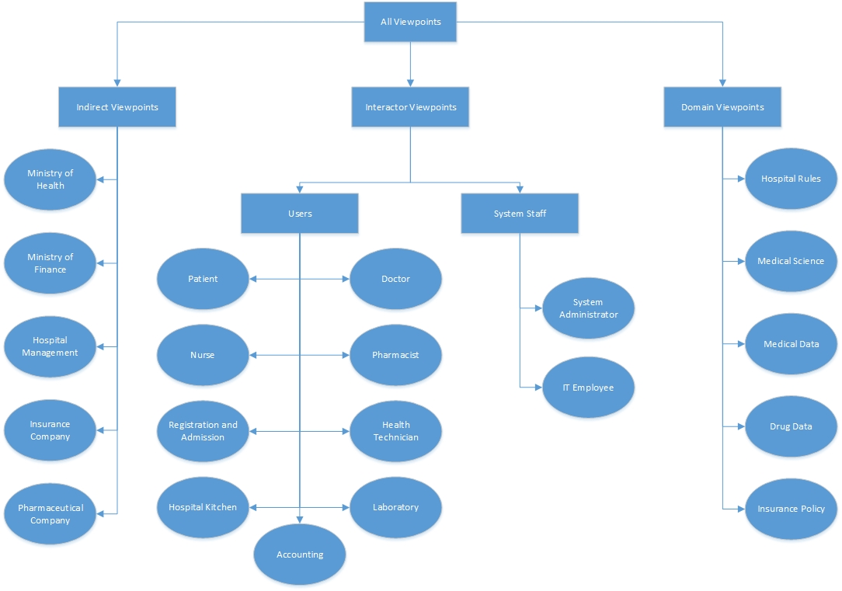

## Requirements of each Viewpoint

### Requirements of the Interactor Viewpoints

|  |  |
| --- | --- |
| Viewpoint | Requirements |
| Patient | Book appointments. |
| View his/her own medical info, prescriptions, appointments, admissions. |
| Get notifications about upcoming events.(appointments, check-ups, etc.) |
| Doctor | View/Add/Update patients medical info, prescriptions, appointments and admissions. |
| Get diagnosis and treatment recommendations from the system. |
| Nurse | View and update patient information. |
| View patient appointments. |
| Pharmacist | View patient prescriptions. |
| Manage medical item stocks. |
| Laboratory | View patient info. |
| Add and update laboratory results. |
| Health Technician | View and update patient information. |
| View patients medical info. |
| Hospital Kitchen | View patients medical info. |
| View patients admission info. |
| Registration and Admission |  |
|  |
| System Administrator | Add New Pharmacy |
| Add New Doctor |
| IT Employee |  |
|  |
| Maintenance Engineer | Maintain the system |
| Optimize the system |

### Requirements of the Indirect Viewpoints

|  |  |
| --- | --- |
| Viewpoint | Requirements |
| Hospital Management |  |
|  |
| Ministry of Health |  |
|  |
| Ministry of Finance |  |
|  |
| Insurence Companies |  |
|  |
| Pharmaceutical Company |  |
|  |

### Requirements of the Domain Viewpoints

|  |  |
| --- | --- |
| Viewpoint | Requirements |
| Hospital Rules |  |
|  |
| Medical Science |  |
|  |
| Medical Data |  |
|  |
| Drug Data |  |
|  |
| Insurance Policy |  |
|  |

# Requirements Definition

## Functional Requirements

|  |  |
| --- | --- |
| Stakeholder | Definition |
|  |  |
|  |  |
|  |  |
|  |  |
|  |  |
|  |  |
|  |  |

## Non-Functional Requirements

|  |  |
| --- | --- |
| Category | Requirement |
|  |  |
|  |  |
|  |  |
|  |  |
|  |  |
|  |  |
|  |  |

## Domain Requirements

|  |  |
| --- | --- |
| Stakeholder / Category | Definition |
|  |  |
|  |  |
|  |  |
|  |  |
|  |  |
|  |  |
|  |  |

## Volatile Requirements

|  |  |
| --- | --- |
| Stakeholder / Category | Definition |
|  |  |
|  |  |
|  |  |
|  |  |
|  |  |
|  |  |
|  |  |

## Enduring Requirements

|  |  |
| --- | --- |
| Stakeholder / Category | Definition |
|  |  |
|  |  |
|  |  |
|  |  |
|  |  |
|  |  |
|  |  |

# Requirements Interviews with Domain Experts

# Requirements Prioritization and Negotiation

# Requirements Traceability Matrix

# Use Cases of Main Scenarios

# Domain Model

# Other Schemas